Junior & Senior Infants Virtual School Tour

Children your Virtual School Tour is to San Diego Zoo.
You will need to go to the airport, so what do you think would be the best way for you to travel to the airport with your friends?

Before we head off to the airport for our virtual school tour of San Diego Zoo
you could perhaps discuss with your child the following questions:

- Where is San Diego Zoo? (an opportunity to take out the globe or atlas)
- What do you call the people that look after the animals?
- Can you name any animals you would see at the zoo?
- What is your favourite animal?
- Have you been to Dublin zoo before?

Before we fly off to San Diego to visit the Zoo:
Have you prepared your packed lunch? (you could have a nice picnic outside)
We mustn’t forget our boarding pass for the airport!

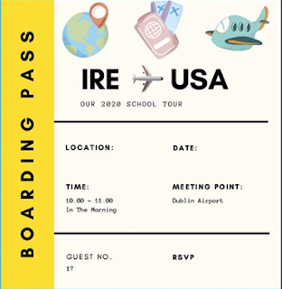

https://kids.sandiegozoo.org/videos

We hope you enjoyed exploring and learning all about San Diego Zoo, why not draw a picture of your favourite animal(s) and send it into us.

Have a look at the Middle & Senior Room Tours if you would like to go on more adventures

